Grade 7 Accelerated · Unit 6  Unit 6 Review  Relationships in Triangles ANSWER KEY | Name  Date  Period

Show your work. Circle your final answer.
HOW TO USE THIS. This review covers every learning target of Lessons 1–8 — more than the test does. Work it in parts. If you miss two or more in a part, that part is where to spend your study time. The reference sheet has everything you need for each part. Thread B's two angle days come after the test and are not on it.
PART A. The Triangle Inequality and the Converse Lessons 1–2 · MA.8.GR.1.3 · 4 questions
1. Can the three lengths be the sides of a triangle? Show the test.
a. 5 cm, 9 cm and 15 cm
No — 5 + 9 = 14 is less than 15.
the two shorter sides against the longest
b. 6 inches, 10 inches and 16 inches
No — 6 + 10 = 16 is equal to the longest side, so the sides lie flat.
equal is not more
c. 11 m, 4 m and 8 m
Yes — 4 + 8 = 12 is more than 11.
the longest is listed first; 11 + 4 tests the wrong pair

2. Two sides of a triangle are 6 ft and 14 ft. Write an inequality for every possible length x of the third side.
8 < x < 20
between the difference, 14 − 6, and the sum, 14 + 6 — never equal to either

3. Is a triangle with these sides a right triangle? Show the test.
a. 65, 33 and 56
Yes — 33² + 56² = 1,089 + 3,136 = 4,225 = 65².
the longest, 65, is c, though it is listed first
b. 7, 8 and 11
No — 49 + 64 = 113, and 11² = 121.
a triangle (7 + 8 > 11), but not a right one

4. Select ALL of the sets of side lengths that make a right triangle.
☐ A. 6, 7, 8
☒ B. 10, 24, 26
☐ C. 3, 4, 7
☐ D. 8, 9, 12
☒ E. 16, 30, 34
B and E
100 + 576 = 676 = 26² and 256 + 900 = 1,156 = 34²: both, and nothing else.

PART B. The Pythagorean Theorem Lesson 3 · MA.8.GR.1.1 · 6 questions
5. A right triangle has legs of 12 ft and 5 ft. How long is the hypotenuse?
13 ft
144 + 25 = 169

6. A right triangle has legs of 3 inches and 13 inches. How long is the hypotenuse, exactly and to the nearest tenth?
√178 in ≈ 13.3 in
9 + 169 = 178

7. A right triangle has a hypotenuse of 85 cm and one leg of 84 cm. How long is the other leg?
13 cm
7,225 − 7,056 = 169

8. A right triangle has a hypotenuse of 11 ft and one leg of 8 ft. How long is the other leg, exactly and to the nearest tenth?
√57 ft ≈ 7.5 ft
121 − 64 = 57

9. Which equation can be used to find x?
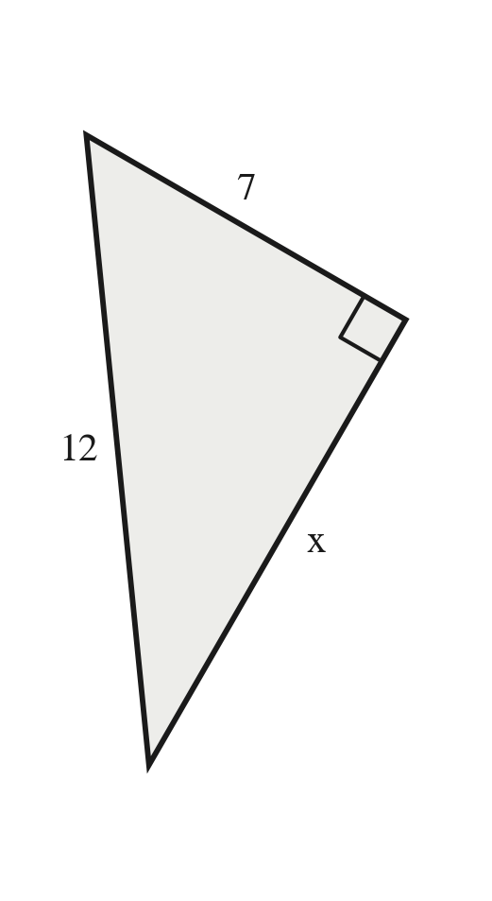
○ A. 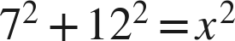
○ B. 
● C. 
○ D. 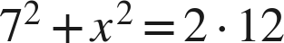
C
The 12 is across from the right angle, so it is c and stands alone: x² = 144 − 49 = 95.

10. Ana finds the missing leg of a right triangle whose hypotenuse is 5 cm and whose other leg is 3 cm. She writes , so the leg is about 5.8 cm. What did she do wrong? Find the leg.
She added the squares, and a leg cannot be longer than the 5-cm hypotenuse. Subtract: 25 − 9 = 16, so the leg is 4 cm.
the error named and the leg found

PART C. The Pythagorean Theorem in Real-World Problems Lesson 4 · MA.8.GR.1.1 · 5 questions
11. A 10-ft ladder leans against a wall with its foot 6 ft from the wall. How high up the wall does it reach?
8 ft
the ladder is c: 100 − 36 = 64

12. A rectangular garden is 10 m long and 11 m wide. How long is a path straight across it from corner to corner, to the nearest tenth of a meter?
About 14.9 m (√221 m)
the diagonal is c: 100 + 121 = 221

13. A ramp rises 1 ft over a run of 9 ft along the ground. How long is the ramp, to the nearest tenth of a foot?
About 9.1 ft (√82 ft)
the ramp is c: 1 + 81 = 82

14. A park is a rectangle 9 m by 11 m. How much shorter is it to walk straight across the park from corner to corner than to walk along two of its sides? Give the answer to the nearest tenth.
About 5.8 m
along two sides 20 m; across √202 ≈ 14.2 m

15. A 9-ft ladder stands with its foot 2 ft from a wall. Will it reach a window ledge 8.5 ft up the wall?
Yes — it reaches √77 ≈ 8.8 ft up the wall, above 8.5 ft.
the height is a leg: 81 − 4 = 77

PART D. Distance on the Coordinate Plane Lesson 5 · MA.8.GR.1.2 · 5 questions
16. Find the distance between the two points.
a. (−6, 2) and (5, 2)
11 units
across zero: 6 + 5
b. (3, −7) and (3, 2)
9 units
across zero: 7 + 2

17. Find the distance between points P and Q.
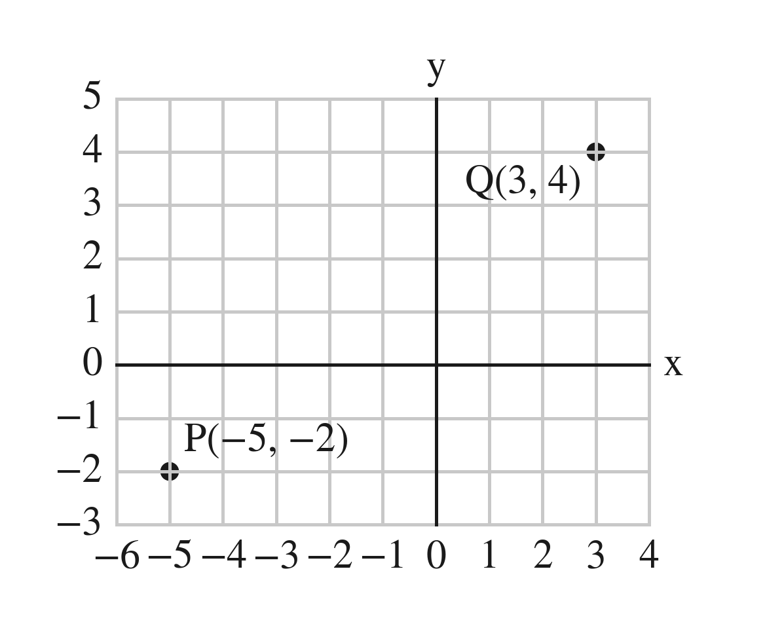
10 units
across 8, up 6: 64 + 36 = 100

18. Find the distance between (−6, −1) and (1, 5), to the nearest tenth.
About 9.2 units (√85)
across 7, up 6: 49 + 36 = 85

19. How far is the point (−1, 6) from the origin? Round your answer to the nearest tenth.
About 6.1 units (√37)
legs 1 and 6: 1 + 36 = 37

20. What is the distance between (−2, −6) and (−2, 3)?
○ A. 3 units
● B. 9 units
○ C. 10 units
○ D. −9 units
B
3 − (−6) = 9: 6 to the axis and 3 past it.

PART E. Coordinate-Plane Problems and Perimeter Lesson 6 · MA.8.GR.1.2 · 4 questions
21. SSDD. Every part below is about one triangle on the grid: P(−4, −4), Q(8, −4), R(8, 5). Same surface, four different questions: a distance on a line (across zero), whether the corner at Q is square, the slanted side as a hypotenuse, and a similar copy (which needs QR, the shortest side, first) — the unit's moves on one triangle, so that a student learns to read the question and not the picture.
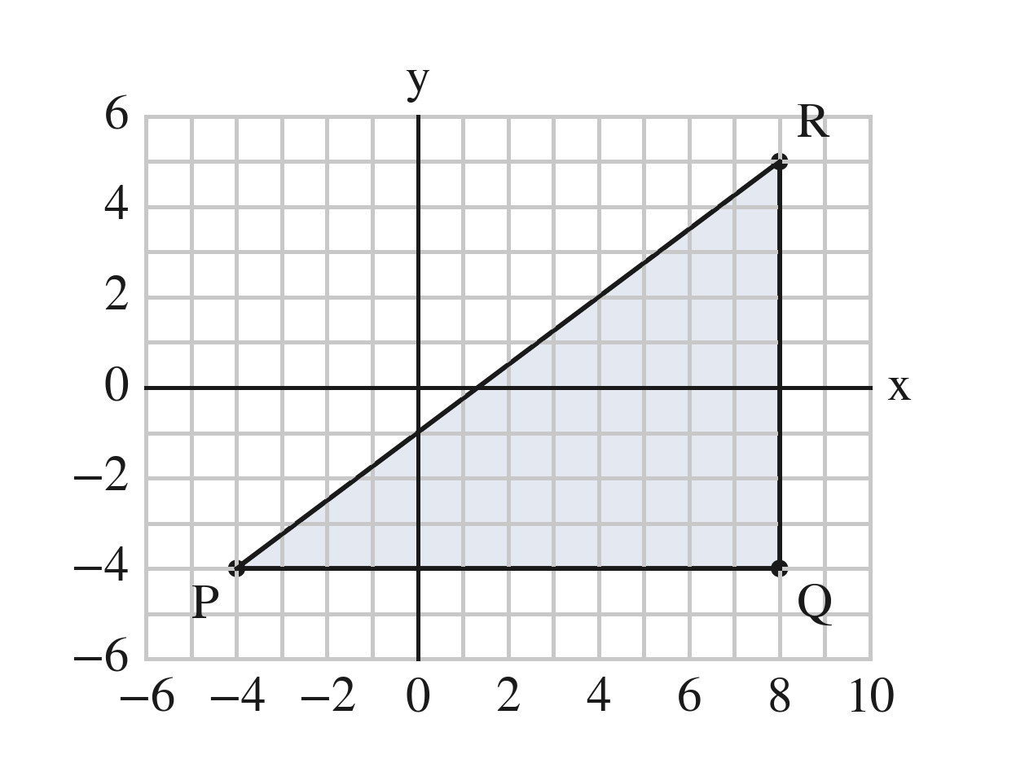
a. Find the length of PQ.
12 units
across zero: 4 + 8
b. Is triangle PQR a right triangle? How do you know?
Yes — PQ runs straight across and QR straight up, so they meet at a right angle at Q.
a horizontal side and a vertical side meet square (and 12² + 9² = 15²)
c. Find the length of PR.
15 units
the hypotenuse of legs PQ = 12 and QR = 5 − (−4) = 9: 144 + 81 = 225
d. A triangle similar to PQR has a shortest side of 3. How long is its longest side?
5
QR = 9 is the shortest side: k = 3 ÷ 9 = 1/3, and 15 × 1/3 — a copy smaller than the original

22. Find the perimeter of the triangle with corners (−4, 2), (6, 2) and (6, −1), to the nearest tenth.
About 23.4 units
10 + 3 + √109; √109 ≈ 10.440 — round once, at the end

23. On a town map in blocks, the school is at (−2, −4) and the park is at (2, 1).
a. How far is it from the school to the park along the streets?
9 blocks
4 across + 5 up
b. How far is it in a straight line? Round your answer to the nearest tenth.
About 6.4 blocks (√41)
16 + 25 = 41

24. A rectangle has corners (−3, −2), (5, −2), (5, 4) and (−3, 4).
a. Find its perimeter.
28 units
8 + 6 + 8 + 6
b. Find the length of one of its diagonals.
10 units
64 + 36 = 100

PART F. Similar Triangles and Indirect Measurement Lessons 7–8 · MA.8.GR.2.4 · 6 questions
25. Are the two triangles similar? Show the three ratios.
a. Sides 5, 7, 8 and sides 15, 21, 24
Yes — 15/5 = 21/7 = 24/8 = 3.
one k for every side
b. Sides 5, 8, 10 and sides 10, 16, 18
No — 10/5 = 16/8 = 2, but 18/10 = 1.8.
two equal ratios are not enough

26. Triangle ABC is similar to triangle DEF. Find x.
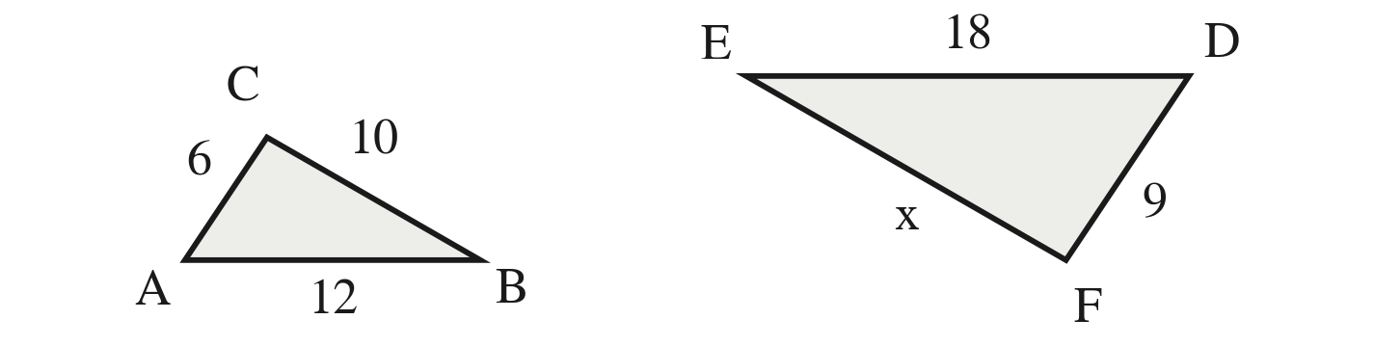
x = 15
The names match AC with DF (6 with 9) and BC with EF, where x is: k = 1.5 and x = 10 × 1.5.

27. A triangle has sides 15, 20 and 30. A similar triangle's middle side is 8. Find its other two sides.
6 and 12
k = 8 ÷ 20 = 0.4 — the copy is smaller

28. A 4-ft fence post casts a 3-ft shadow. At the same moment, a tree casts a 21-ft shadow. How tall is the tree?
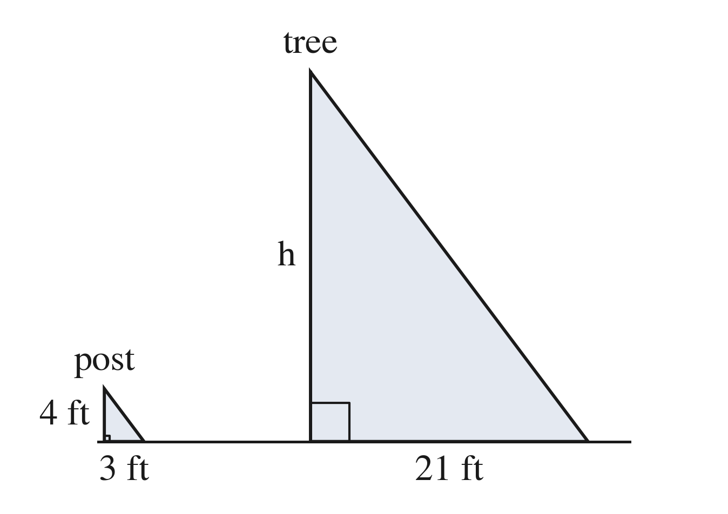
28 ft
k = 21 ÷ 3 = 7 from the shadows; 4 × 7

29. Kai's eyes are 5 ft above the ground. He stands 3 ft from a mirror on the ground and sees in it the top of a pole that stands 12 ft beyond the mirror. The two right triangles are similar. How tall is the pole?
20 ft
k = 12 ÷ 3 = 4; 5 × 4

30. Which triangle is similar to one with sides 6, 8 and 9?
○ A. 8, 10, 11
○ B. 12, 16, 20
● C. 9, 12, 13.5
○ D. 6, 8, 12
C
Every side × 1.5.

